K-Nearest Neighbors
Code:
import pandas as pd
import seaborn as sns
import matplotlib.pyplot as plt
import numpy as np

df = pd.read_csv('/content/Classified Data', index_col=0)

print(df.head())
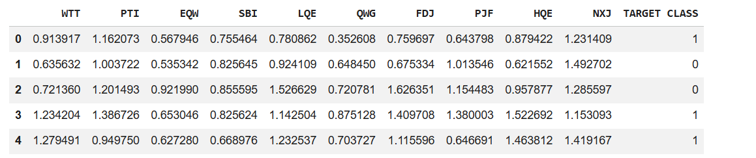

from sklearn.preprocessing import StandardScaler

scaler = StandardScaler()
scaler.fit(df.drop('TARGET CLASS', axis=1))
scaler_features = scaler.transform(df.drop('TARGET CLASS', axis=1))

df_feat = pd.DataFrame(
scaler_features,
columns=df.columns[:-1]
)
print(df_feat.head())
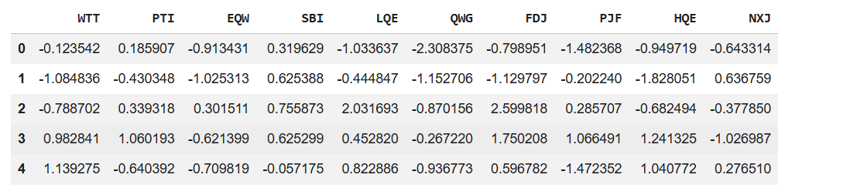

from sklearn.model_selection import train_test_split

X_train, X_test, y_train, y_test = train_test_split(
scaler_features,
df['TARGET CLASS'],
test_size=0.3,
random_state=101
)

from sklearn.neighbors import KNeighborsClassifier
from sklearn.metrics import confusion_matrix

knn = KNeighborsClassifier(n_neighbors=1)
knn.fit(X_train, y_train)

pred = knn.predict(X_test)
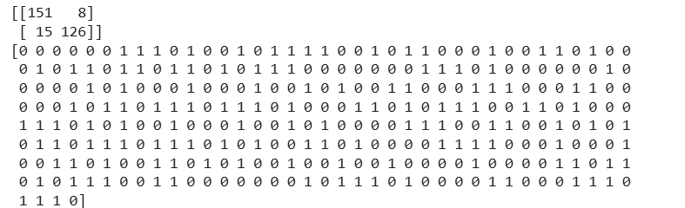

print("Confusion Matrix:")
print(confusion_matrix(y_test, pred))

print("Predictions:")
print(pred)

from sklearn.metrics import classification_report

print("Classification Report:")
print(classification_report(y_test, pred))
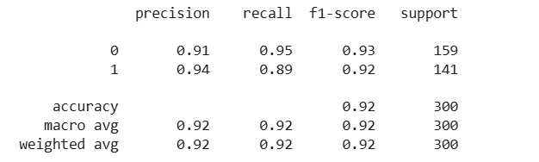

error_rate = []

for i in range(1, 40):
knn = KNeighborsClassifier(n_neighbors=i)
knn.fit(X_train, y_train)
pred_i = knn.predict(X_test)
error_rate.append(np.mean(pred_i != y_test))

plt.figure(figsize=(10, 6))

plt.plot(
range(1, 40),
error_rate,
color='blue',
linestyle='dashed',
marker='o',
markerfacecolor='red',
markersize=10
)
plt.title('Error Rate vs. K Value')
plt.xlabel('K')
plt.ylabel('Error Rate')
plt.show()

Output:
